|  |
| --- |
|  |
| Orenda Marine Engines |
| Trailer Traffic Control System |
|  |
| **JGRC Consulting** |
|  |

|  |
| --- |
| **October 11, 2012** |

Table of Contents

Executive Summary 2

Arrivals 3

Overview 3

Operational Hours Arrivals 3

Non-Operational Hours Arrivals 3

Trailer Movements 4

Request for components 4

Request for Driver 5

Request for Empty Trailer 6

Request for Empty Trailer Removal 7

Departures 8

Overview 8

Releasing empty trailer 8

Shipping to end customer 8

Conclusion 9

Appendix A: Arrivals 10

Appendix B: Trailer Movements 14

Appendix C: Departures 24

Appendix D: Slide Show 28

Executive Summary

JGRC Consulting has been tasked with analyzing and optimizing the current Trailer Traffic Control System as used by Orenda Marine Engines. Our goal is to fully replace the current TTCS with a system designed from the ground up. As our first step we have analyzed the current system through research and interviews, and what follows is an explanation of our findings.

The current system consists of three major components: Arrivals, Departures, and internal Movements. We have analyzed and discussed in detail the findings, and the issues with the current system and processes.

The Arrivals process focuses on trailers arriving at Orenda’s lot, the process involved in being approved for intake, and the storage of newly arrived trailers in the lot. This process is further split into arrivals during operational hours, and those outside the operation hours. Also touched on is the rejection of trailers, though this is somewhat outside the scope of the system.

The Movements is the largest and most complex process involved, covering requests for components, empty trailers, trailer removals, drivers, and finished products, all to be shuffled between the storage yard and the warehouse, and the storage yard and the manufacturing plant.

The Departures process involves the release of empty trailers back to their respective shipping companies, as well as the delivery of finished products to the end customer. The removal of the trailers from the system is also included in the Departures process.

Graeme McBriarty

Arrivals

## Overview

A core part of the production process is the receipt of parts. This is done through the coming and going of trailers from the Orenda Marine Engines facility. The arrivals process of Orenda Marine Engines can be broken down into two main processes: the trailers that arrive during operational hours, and those that don’t.

## Operational Hours Arrivals

When a trailer arrives at the OME facility it is required to report to the dispatch office where they will submit their Bill of Lading. The door seal is checked against the Bill of Lading to ensure that the numbers match and that the seal is unbroken. If, there is any abnormality the driver is refused entry until the contents of the trailer have been verified at a higher level. Once, the trailer is cleared the all of the information from the Bill of Lading is entered into the system manually to create the trailer record.

## Non-Operational Hours Arrivals

When a trailer arrives after hours the security guard receives the bill of lading and checks the seal number and the trailer number against the one on the bill of lading to ensure everything is correct. If it is, the trailer is admitted and instructed to find the first available spot to park. If not, the trailer is instructed to return during the normal business hours of 0600 to 1800. When a trailer is admitted it is recorded on the after-hours arrival log with the date, time, trailer number, seal number remarks and who accepted it, the bill of lading is then placed with the After Hours Arrival log for the dispatcher when he arrives in the morning.

The next morning that the dispatch office is open the Dispatcher takes the After Hours arrival log along with the bills of lading and manually goes out and searches for the trailers in the yard to identify where the trailer was parked when it arrived. When has located all of the trailers he then enters all of the information from each Bill of Lading into the system.

## Identified Problems

When a trailer arrives after hours, the security guard does not log the parking spot. The dispatcher has to then manually locate the trailer in the lot which requires him to be out of the dispatch office and takes time that could be used for other processes.

When a trailer record is being created the Bill of Lading is required to be manually entered into the TTCS which is a time consuming process that takes the dispatchers’ time that could be used for other tasks.

Corey Despres

Trailer Movements

## Request for Components

The process of requesting components is a frequent one. All requests are initiated from the dock foreman to the dispatcher. The dock foreman must provide the part number, along with the destination bay number. The dispatcher identifies an available driver, along with the number of the trailer in which the components required are located. The dispatcher then radios the driver to provide them with the destination bay and trailer number. The driver proceeds to the yard to pick up the trailer and deliver it to destination bay. The driver decides if they want to wait for the trailer to get unloaded or radio back in to notify dispatcher of availability. Unloading trailers typically take anywhere from 15 minutes to 2 hours.

## Identified Problems

The first problem encountered is tracking components in the TTCS. This consists of searching a list for a specific part number, scrolling through an arbitrarily ordered list. The ability to search or perform queries based on single or multiple inputs is not an option. The dispatcher effectively wastes their time using the TTCS to track components.

Another issue is that there is no policy in place governing what drivers need to do after delivering components to the dock. It is expected that they either wait for the trailer to be unloaded so they can proceed to deliver the trailer back to the yard, or that they radio back into the dispatcher to indicate that they are available for work.

It is possible that the driver radios in and tells the dispatcher they have become available, but the dispatcher keeps track of this in their head, which leads to forgetting who is available and who is tied up with a job. It could become an issue if the dispatcher believes he has no available driver, while the driver is sitting idly waiting to be notified of further jobs.

Jack Watt

## Request for Driver

Requesting a driver when one is not present at dock is initiated by the dock foreman to the dispatcher, providing the destination bay number. The dispatcher then identifies an available driver. The dispatcher radios the driver to inform them of the bay number to which they are to report. The driver arrives with their truck at the bay requested.

There could be many reasons why a driver is needed to report at the docks. In most cases when trailers are shuttled to the docks the driver has the choice to wait or not. If they do not wait, this leaves the docks in a situation where they would need another driver. Identifying available drivers is the work of the dispatcher. Managing the drivers’ time is a task of their own.

## Identified Problems

The first problem with this process is that the drivers have no policy on what to do when they drop off the trailers; this leaves a hole in the current process by making it difficult to reach drivers and track where they are. Tracking the drivers is the job of the dispatcher, but with no policy in place on what they do when they shuttle the trailers to the docks makes knowing who is available and who is not a frustrating task.

It is a problem if the dispatcher believes someone is working who is in fact waiting for their next job. This would be a break in communication, an oversight, rather than being intentional by the drivers.

Jack Watt

## Request for Empty Trailer

The dock foreman makes a request to the dispatcher by phone for an empty trailer, providing the dispatcher with a bay number. The dispatcher indentifies an available trailer and driver. The dispatcher radios the driver providing them with the bay and trailer number. The driver picks up the trailer and shuttles it to the dock from the yard. The driver then decides whether to wait for the trailer to be loaded, or can radio in their availability.

All trailers must be shuttled from the yard to the dock, and from the yard to the warehouse. Policy is put in place to prevent from an empty trailer from being sent directly from the warehouse to the plant.

## Identified Problems

The policy of trailers only being able to be shuttled from the yard to the warehouse, and from the yard to the docks is not always being followed. This policy is put in place to prevent trailers from being left at the warehouse or the dock. All trailers need to be left in the yard, the only secure area.

Certain trailers belong to certain companies. It could become a problem that trailer type is not associated with product type. Some drivers will only leave with the trailer they came with or another trailer from the same company.

Ryan Vaughan

## Request for Empty Trailer Removal

This process begins when a trailer has been emptied at a dock of the Warehouse or Plant, and the driver does not wait for the trailer to be unloaded. Once the Dock Foreman identifies that there is an empty trailer at the dock, he or she will call the dispatcher requesting a driver to come pick it up.

The Dock Foreman provides the dispatcher with the appropriate information. This includes the dock name and bay number at which the trailer is located, as well as the trailer number of the trailer. Once this call has been placed, the dispatcher must now find a driver to perform this task (See Use Case JGRC-2002).

The dispatcher must determine where the empty trailer will be placed in the yard after it is picked up. The dispatcher will provide the driver with the information given to him from the Dock Foreman as well as the end destination, determined beforehand. This process concludes when the trailer has been removed from the dock and placed in the specified parking spot in the yard.

## Identified Problems

One issue that can be encountered in this process is that the dispatcher may not always get the required information for pick-up. He may only get the bay number or the trailer number and this can cause problems for the driver. Without the appropriate information, the driver will have to search for the correct dock or for the specific trailer at the docks. This is very time consuming and slows down an otherwise simple process.

Another issue is when a driver cannot be reached or is late. In either of these situations, the trailer will have to sit and wait at the bay. The main concerns here are that the trailers are unattended in an unsecure area, and that the empty trailer is now taking up a bay.

Ryan Vaughan

Departures

## Overview

There are two possible departures for the trailers at Orenda. The first is if a trailer is filled with goods and products to be shipped to the customer. The second is if the trailer is due or overdue to be returned to the Shipping Company that provided the trailer in the first place.

## Shipping to end customer

After a shipping company driver drops off their trailer in the lot, they typically pick up another trailer owned by their employer. There may be a trailer loaded with goods, predetermined to be picked up by the shipping company driver. The dispatcher will check if there are any loads for the driver. These will have been loaded at a dock, and are waiting for pickup. The shipping company driver will deliver the products to the end customers.

## Releasing empty trailer

If there are no loaded trailers for the driver, the dispatcher will look at the return-by dates of the trailers in the system, as well as the shipping company owning the particular trailer, and the number of empty trailers available for transferring parts. Taking these three factors in to consideration, they may choose to release an empty trailer to the shipping company driver.

In either case, the dispatcher will then note in the system that that particular trailer is no longer taking up space in the lot, and has been returned to the shipping company.

## Identified Problems

The current problems mainly involve the overdue fees on releasing trailers to the shipping companies which own them. There needs to be a more efficient way to track the requirement of empty trailers, and which trailers are causing the most impact in regards to late fees. Another issue may involve the conflict between the dispatcher and the shipping company drivers when there are no trailers to release, and no shipments to be made.

Graeme McBriarty

Conclusion

JGRC Consulting has concluded after analysis of the current Trailer Traffic Control System that the system is not being fully utilized. What we have gathered through the interview and research process is that the current system is out of date, and does not mirror the processes of Orenda Marine Engines well. Out of the three major components - Arrivals, Departures, and internal Movements - loss of time is incurred through a breakdown in communication, which leads to a loss of productivity.

Problems with the Arrivals process for tracking after hours arrivals have surfaced in our analysis. The security guard does not log the parking spot. The dispatcher has to then manually locate the trailer in the lot which requires him to be out of the dispatch office and take time that could be used otherwise. Trailer records being created can also be a concern. The bill of lading is manually entered into the TTCS, in a slow manual process.

At the heart of this system, the main functionality, is trailer movements. This is the biggest process in the system. The most significant breakdown in this process would be lost time, with the drivers not having a policy in place for when they deliver trailers. In most cases they have the opportunity to wait or to radio on availability. With the dispatcher keeping track of this in their head it can lead to a loss of time by forgetting who is working, and who is waiting for their next job.

Trailer departures can be broken down into two main issues. The first is tracking what trailers are incurring the most late fees, as the rates differ depending on how long the trailer has been overdue. The second is conflict between dispatcher and the shipping company drivers when there are no trailers to release. Drivers will want to leave with product to ship or with an empty trailer.

Jack Watt

# Appendix A: Arrivals

## Operation Hours Arrivals

|  |  |  |  |  |
| --- | --- | --- | --- | --- |
| **Author** | Corey Despres | | **Date** | October-01-2012 |
| **Version** | 1.0 | |  | |
| **Use Case Name** | Operation Hours Arrivals | | **Use Case Type:** | |
| **Use Case ID** | JGRC-1001 | | **Business Requirements**  **System Analysis** | |
| **Priority** | HIGH | |
| **Source** | Requirement | | | |
| **Primary Business Actor** | Dispatcher | | | |
| **Other Participating Actors** | Driver | | | |
| **Other Interested Stakeholders** | Dock Foreman  Production Manager | | | |
| **Description** | This use case describes the event of a trailer arriving at the facility seeking admission. The dispatcher must verify the trailer and seal against the provided bill of lading as well as check for any other abnormalities. | | | |
| **Precondition(s)** | The trailer arrives at the facility | | | |
| **Trigger(s)** | The trailer arrives at the dispatch office | | | |
| **Typical Course of Events** | **Actor Action** | **System Response** | | |
| **Step 1:** The trailer arrives at the dispatch office  **Step 3:** The dispatcher requests the Bill of Lading  **Step 5:** The dispatcher compares the trailer number and the seal to the number on the bill of lading. As well as checks the trailer for any abnormalities. The dispatcher then clears the trailer for entrance and assigns the trailer a spot within the secure parking area  **Step 7:** The dispatcher returns to the Dispatch Office and enters the trailer information from the bill of lading into the system | **Step 2:** none  **Step 4:** none  **Step 6:** none  **Step 8:** The information is stored into the system. The TTCS informs the MMS that the parts have arrived | | |
| **Alternate Courses** | **Actor Action** | **System Response** | | |
| **Step 5:** If the seal is broken or there are any abnormalities the dispatcher informs the Production Manager for further action. If the Production Manager verifies it is all correct it is admitted entry. | | | |
| **Conclusion** | The use case concludes when the trailer information in saved within the system | | | |
| **Postcondition** | The trailer is admitted and parked in the Parking area and the trailer information is entered into the system. | | | |
| **Business Rules** |  | | | |
| **Implementation Constraints and Specifications** | * Use Case must be available during normal operational hours * Frequency : It is estimated that the use case will be used multiple times per day on an as needed basis | | | |
| **Assumptions** | * Bill of Lading is available * Dispatcher is at the office | | | |
| **Open Issues** | None | | | |

## Non-Operational Hours Arrivals

|  |  |  |  |  |
| --- | --- | --- | --- | --- |
| **Author** | Corey Despres | | **Date** | October-02-2012 |
| **Version** | 1.0 | |  | |
| **Use Case Name** | Non-Operational hours arrivals | | **Use Case Type:** | |
| **Use Case ID** | JGRC-1002 | | **Business Requirements**  **System Analysis** | |
| **Priority** | HIGH | |
| **Source** | Requirement | | | |
| **Primary Business Actor** | Security Guard | | | |
| **Other Participating Actors** | Driver | | | |
| **Other Interested Stakeholders** | Dispatcher  Dock Foreman | | | |
| **Description** | This use case describes the event of a trailer arriving at the facility after operational hours seeking admission. The security guard must verify the trailer and seal number against the provided bill of lading as well as check for an abnormalities. The security guard must then record the relevant information on the after-hours arrival log. | | | |
| **Precondition(s)** | The trailer arrives at the facility | | | |
| **Trigger(s)** | The trailer arrives at the dispatch office | | | |
| **Typical Course of Events** | **Actor Action** | **System Response** | | |
| **Step 1:** The trailer arrives at the dispatch office  **Step 3:** The security guard requests the Bill of Lading  **Step 5:** The security guard compares the trailer number and seal number to the number on the bill of lading. As well as checks the trailer for any abnormalities. The security guard then clears the trailer for entrance and instructs the trailer to park in the first available space within the parking area  **Step 7:** The Security Guard then returns to the Dispatch office and records the Date, Time, Trailer Number, Seal Number and any Remarks on the After Hours arrival log  **Step 9:** The next business day the Dispatcher enters the trailer information from the bill of lading into the system | **Step 2:** none  **Step 4:** none  **Step 6:**none  **Step 8:**none  **Step 10:** The information is stored into the system. The TTCS informs the MMS that the parts have arrived. | | |
| **Alternate Courses** | **Actor Action** | **System Response** | | |
| **Step 5:** If the seal is broken or there are any abnormalities the trailer is instructed to return during operational hours. Invokes Use Case JGRC-1001. | | | |
| **Conclusion** | The use case concludes when the trailer information is recorded on the After Hours arrival log | | | |
| **Postcondition** | The trailer is admitted and parked in the Parking Area and the information is recorded on the After Hours Arrival log. | | | |
| **Business Rules** |  | | | |
| **Implementation Constraints and Specifications** | * This use case must be available during non-operational business hours * Frequency: This use case is intended to be used on an as needed basis | | | |
| **Assumptions** | * Bill of Lading is available * Security Guard is at the office | | | |
| **Open Issues** | None | | | |

**Figure A – Bill of Lading**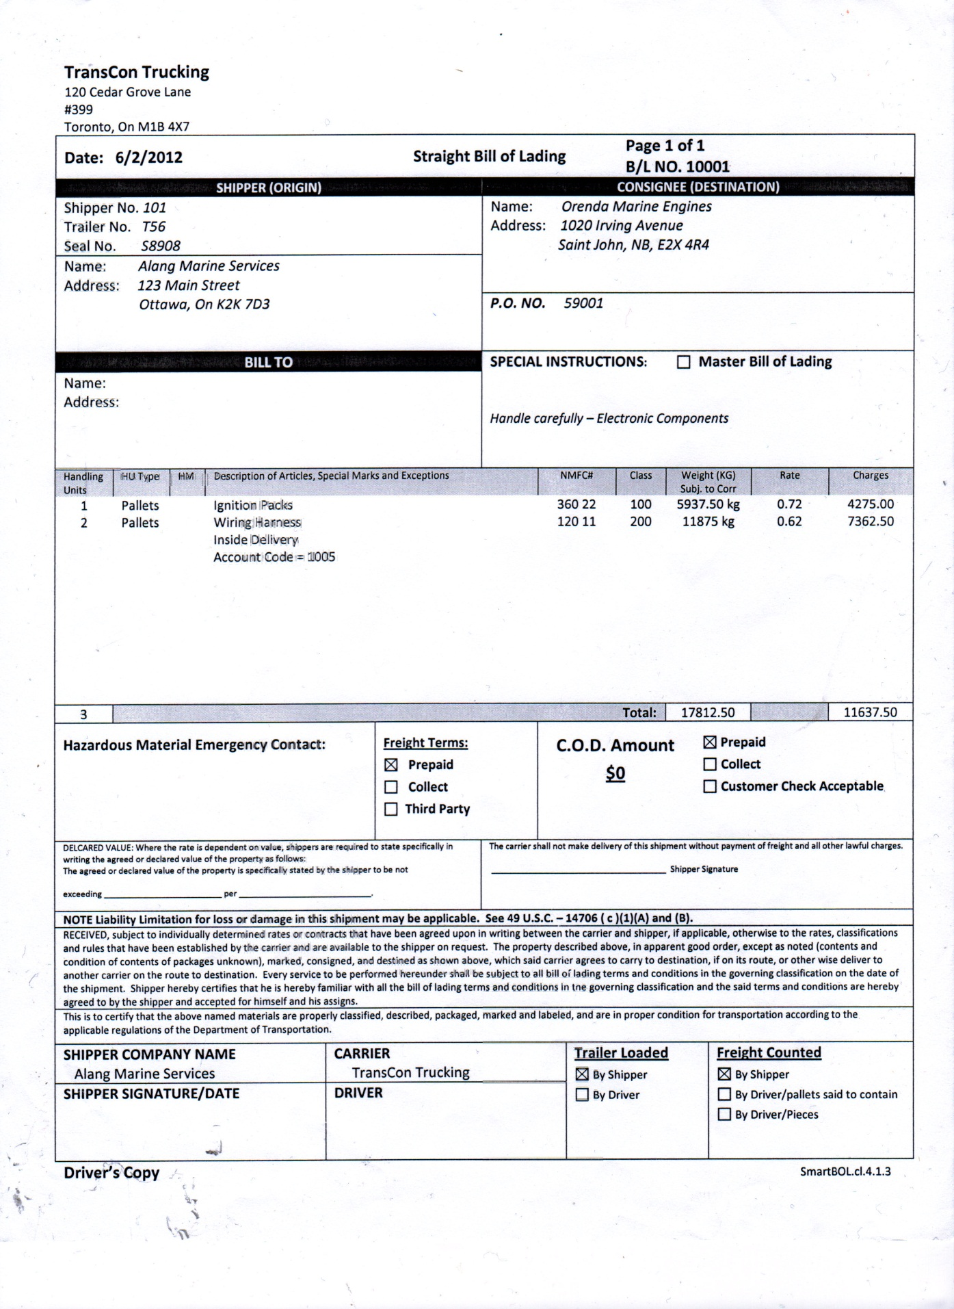

**Figure B – After Hours Arrival Log**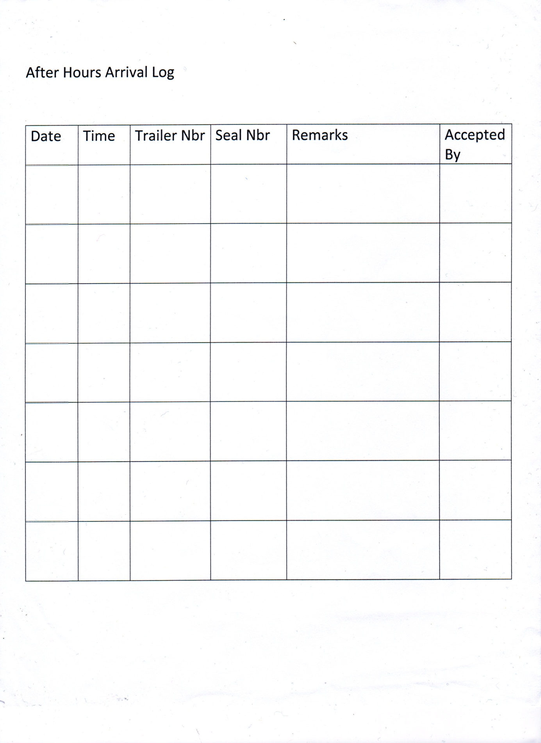

# Appendix B: Trailer Movements

## Request for Components

|  |  |  |  |  |
| --- | --- | --- | --- | --- |
| **Author** | Jack Watt | | **Date** | October-05-2012 |
| **Version** | 1.0 | |  | |
| **Use Case Name** | Request for components | | **Use Case Type:** | |
| **Use Case ID** | JGRC-2001 | | **Business Requirements**  **System Analysis** | |
| **Priority** | HIGH | |
| **Source** | Requirement | | | |
| **Primary Business Actor** | Dock foreman | | | |
| **Other Participating Actors** | Dispatcher , Driver | | | |
| **Other Interested Stakeholders** |  | | | |
| **Description** | This use case describes the event of requesting components from the warehouse to the docks. The dock foreman must notify the dispatcher of what components are needed. The dispatcher takes the part number, and the dock to be delivered to. Driver takes location of trailer from dispatcher, picks up trailer from yard, and delivers it to destination bay at dock. | | | |
| **Precondition(s)** | Production makes request for components | | | |
| **Trigger(s)** | This use case is triggered when Components are requested | | | |
| **Typical Course of Events** | **Actor Action** | **System Response** | | |
| **Step 1:** Foreman makes request to Dispatcher by phone for Components. Providing part number and destination bay.  **Step 3:** Dispatcher radios available driver providing trailer number and destination bay  **Step 5:** Driver picks up trailer in yard and shuttles to requested bay on dock. | **Step 2:** Dispatcher searches TTCS for bill of lading to find out what trailer it’s in  **Step 4:** none  **Step 6:** none | | |
| **Alternate Courses** | **Actor Action** | **System Response** | | |
|  |  | | |
| **Conclusion** | This use case concludes when driver delivers trailer with components to destination bay. | | | |
| **Postcondition** | The trailer is now at bay, driver radios in to notify dispatcher of availability if not waiting for truck to be finished unloading. | | | |
| **Business Rules** | * Dock foreman must provide part number and destination bay to Dispatcher * Dispatcher provides what trailer is needed to driver by radio * Driver shuttles trailer from yard to Bay * Driver decides to wait to be unloaded or radios in availability to dispatcher | | | |
| **Implementation Constraints and Specifications** | * Varies how often this process will be invoked, estimated at 4-5 times a day * Not performed after hours | | | |
| **Assumptions** | * Trailer is in yard * A driver is available * Destination bay is empty * Frequency: This use case is intended to be used on an as needed basis | | | |
| **Open Issues** | * Driver making decision to wait or radioing in for availability can lead to lost time with drivers. | | | |

## Request for Driver

|  |  |  |  |  |
| --- | --- | --- | --- | --- |
| **Author** | Jack Watt | | **Date** | October-05-2012 |
| **Version** | 1.0 | |  | |
| **Use Case Name** | Request for driver | | **Use Case Type:** | |
| **Use Case ID** | JGRC-2002 | | **Business Requirements**  **System Analysis** | |
| **Priority** | HIGH | |
| **Source** | Requirement | | | |
| **Primary Business Actor** | Dock foreman | | | |
| **Other Participating Actors** | Dispatcher, Driver | | | |
| **Other Interested Stakeholders** |  | | | |
| **Description** | This use case describes the event of requesting a driver when one isn’t present at docks | | | |
| **Precondition(s)** | * Production makes request for driver * No driver is present at dock | | | |
| **Trigger(s)** | This use case is triggered when Driver is needed and not present at docks | | | |
| **Typical Course of Events** | **Actor Action** | **System Response** | | |
| **Step 1:** Plant requests driver by phone to dispatch, providing bay number  **Step 3:** Dispatcher identifies available driver  **Step 5:** Dispatcher radios driver with bay number  **Step 7:** Driver shuttles trailer to bay | **Step 2:** none  **Step 4:** none  **Step 6:** none | | |
| **Alternate Courses** | **Actor Action** | **System Response** | | |
|  |  | | |
| **Conclusion** | This use case concludes when driver arrives at docks. | | | |
| **Postcondition** | The Driver is now at bay, available to carry out task requested for. | | | |
| **Business Rules** | * Dock foreman must provide destination bay to Dispatcher * Driver carries out task requested for | | | |
| **Implementation Constraints and Specifications** | * Varies how often this process will be invoked. * Not performed after hours * Frequency: This use case is intended to be used on an as needed basis | | | |
| **Assumptions** | * A driver is available * Driver has their own truck | | | |
| **Open Issues** | * Nothing in place with TTCS to track drivers or manage their time. | | | |

## Request for Empty Trailer

|  |  |  |  |  |
| --- | --- | --- | --- | --- |
| **Author** | Ryan Vaughan | | **Date** | October-05-2012 |
| **Version** | 1.0 | |  | |
| **Use Case Name** | Request for empty trailer | | **Use Case Type:** | |
| **Use Case ID** | JGRC-2003 | | **Business Requirements**  **System Analysis** | |
| **Priority** | HIGH | |
| **Source** | Requirement | | | |
| **Primary Business Actor** | Dock Foreman | | | |
| **Other Participating Actors** | Dispatcher , Driver | | | |
| **Other Interested Stakeholders** |  | | | |
| **Description** | This use case describes the event of requesting an empty trailer to move finished product from the plant to the warehouse. | | | |
| **Precondition(s)** | Production makes request for empty trailer | | | |
| **Trigger(s)** | This use case is triggered when empty trailers are requested | | | |
| **Typical Course of Events** | **Actor Action** | **System Response** | | |
| **Step 1:** Plant contacts dispatch by phone to request empty trailer from yard to move finished product to warehouse. Giving dispatch bay number  **Step 3:** Dispatch identifies available empty trailer from TTCS  **Step 5:** Dispatch radios available driver giving them trailer number and destination bay.(Invokes JGRC-2002)  **Step 7:** Driver shuttles trailer to destination bay. . | **Step 2:** none  **Step 4:** TTCS displays list of trailers  **Step 6:** none  **Step 8:**none | | |
| **Alternate Courses** | **Actor Action** | **System Response** | | |
|  |  | | |
| **Conclusion** | This use case concludes when empty trailer is delivered to dock. | | | |
| **Postcondition** | The trailer is now at bay, driver radios in to notify dispatcher of availability if not waiting for truck to be finished unloading. | | | |
| **Business Rules** | * Dock foreman must provide destination bay to Dispatcher * Driver shuttles trailer from yard to Bay | | | |
| **Implementation Constraints and Specifications** | * Frequency: This use case is intended to be used on an as needed basis * Not performed after hours | | | |
| **Assumptions** | * Trailer is in yard * A driver is available * Destination bay is empty | | | |
| **Open Issues** | * Driver making decision to wait or radio in for availability can lead to lost time with drivers. | | | |

## Request for Empty Trailer Removal

|  |  |  |  |  |
| --- | --- | --- | --- | --- |
| **Author** | Ryan Vaughan | | **Date** | October-2-2012 |
| **Version** | 1.0 | |  | |
| **Use Case Name** | Request for empty trailer removal | | **Use Case Type:** | |
| **Use Case ID** | JGRC-2004 | | **Business Requirements**  **System Analysis** | |
| **Priority** | HIGH | |
| **Source** | Requirement | | | |
| **Primary Business Actor** | Dispatcher | | | |
| **Other Participating Actors** | Dock Foreman, Driver | | | |
| **Other Interested Stakeholders** |  | | | |
| **Description** | This use case describes the process followed by the Dispatcher when a request is made by the Dock Foreman, of either the warehouse or plant, to have an empty trailer removed from a bay. | | | |
| **Precondition(s)** |  | | | |
| **Trigger(s)** | Trailer is unloaded at the Warehouse or Plant | | | |
| **Typical Course of Events** | **Actor Action** | **System Response** | | |
| **Step 1**: Dock Foreman calls dispatch to send a driver to pick up trailer  **Step 3**: Dock Foreman provides Dispatch with Trailer number and at which bay it is located  **Step 5**: Dispatch radios for a driver (invokes use case JGRC-2002)  **Step 7**: Driver picks up the empty trailer from bay specified and takes it to a specified parking spot | **Step 2**: none  **Step 4**: none  **Step 6**: none  **Step 8:** none | | |
| **Alternate Courses** | **Actor Action** | **System Response** | | |
|  | | | |
| **Conclusion** | This use case concludes when the trailer has been placed back in the yard | | | |
| **Postcondition** | The empty trailer is now located in the yard waiting to be used for shuttling components and shipping finished products. | | | |
| **Business Rules** | * Dock Foreman must provide Dispatch with Dock, Bay and Trailer information of the trailer waiting to be picked up. * Dispatch provides Driver with the same information given by Dock Foreman as well as the end destination of trailer. | | | |
| **Implementation Constraints and Specifications** | * Frequency: This use case is intended to be used on an as needed basis * Not performed after hours | | | |
| **Assumptions** | * Dock Foreman always provides required information. * Driver did not wait for trailer to be unloaded | | | |
| **Open Issues** | * Information given to Dispatch varies. * Trailer may wait for a while if driver can’t be reached. | | | |

# Appendix C: Departures

## Shipping Departure

|  |  |  |  |  |
| --- | --- | --- | --- | --- |
| **Author** | Graeme McBriarty | | **Date** | October-06-2012 |
| **Version** | 1.0 | |  | |
| **Use Case Name** | Shipping Departure | | **Use Case Type:** | |
| **Use Case ID** | JGRC-3001 | | **Business Requirements**  **System Analysis** | |
| **Priority** | HIGH | |
| **Source** | Requirement | | | |
| **Primary Business Actor** | Dispatcher | | | |
| **Other Participating Actors** | Shipping Company Driver | | | |
| **Other Interested Stakeholders** |  | | | |
| **Description** | This use case describes a Dispatcher releasing a trailer loaded with product to a Shipping Company driver, to be delivered to an end customer. | | | |
| **Precondition(s)** | There is a trailer at a bay that belongs to the Shipping Company that the driver is employed by, loaded with the finished products for delivery. | | | |
| **Trigger(s)** | A Shipping Company driver successfully drops off a trailer (see JGRC-1001) | | | |
| **Typical Course of Events** | **Actor Action** | **System Response** | | |
| **Step 1:** Dispatcher is informed that the shipping company driver will be picking up a shipment  **Step 3:** The dispatcher informs the Shipping Company driver of the trailer location. | **Step 2:** none  **Step 4:** Trailer record marked as removed/returned to S.C. | | |
| **Alternate Courses** | **Actor Action** | **System Response** | | |
| **Step 5:** If no trailers with product to ship, may invoke JGRC-3002. Also may be sent without a trailer, but this is not ideal. | **Step 6:** Trailer record marked as removed | | |
| **Conclusion** | Concludes with a Shipping Company Driver departing with a trailer belonging to their employer, filled with product to be delivered to the customer. | | | |
| **Postcondition** | One more lot space is empty. One trailer marked as removed from system/returned to S.C. | | | |
| **Business Rules** |  | | | |
| **Implementation Constraints and Specifications** | * Frequency: This use case is intended to be used on an as needed basis * Not performed after hours. | | | |
| **Assumptions** | * There are trailers (belonging to the specific Shipping Company) that have been loaded with product. * The S.C. driver has been tasked with delivering a loaded trailer. | | | |
| **Open Issues** | * If there are no trailers with products, then the shipping company driver may not depart with a trailer. | | | |

## Empty Departure

|  |  |  |  |  |
| --- | --- | --- | --- | --- |
| **Author** | Graeme McBriarty | | **Date** | October-05-2012 |
| **Version** | 1.0 | |  | |
| **Use Case Name** | Empty Departure | | **Use Case Type:** | |
| **Use Case ID** | JGRC-3002 | | **Business Requirements**  **System Analysis** | |
| **Priority** | HIGH | |
| **Source** | Requirement | | | |
| **Primary Business Actor** | Dispatcher | | | |
| **Other Participating Actors** | Shipping Company Driver | | | |
| **Other Interested Stakeholders** |  | | | |
| **Description** | This use case describes a Dispatcher releasing an empty trailer back to a Shipping Company driver. | | | |
| **Precondition(s)** | There is an empty trailer in the lot that belongs to the Shipping Company that the driver is employed by.  The Dispatcher determines that a trailer can be released | | | |
| **Trigger(s)** | A Shipping Company driver successfully drops off a trailer (see JGRC-1001) | | | |
| **Typical Course of Events** | **Actor Action** | **System Response** | | |
| **Step 1:** Dispatcher looks over records of trailers in lot.  **Step 3:** If a trailer is both overdue, and the dispatcher determines that there are sufficient empty trailers in the lot, then releases trailer to S.C. driver, and removes trailer from system. | **Step 2)** Returns return-by dates of trailers  **Step 4)** Trailer record marked as removed. | | |
| **Alternate Courses** | **Actor Action** | **System Response** | | |
|  |  | | |
| **Conclusion** | Concludes with a Shipping Company Driver departing with an empty trailer belonging to their employer. | | | |
| **Postcondition** | One more lot space is empty. One trailer marked as removed from system. | | | |
| **Business Rules** | * Releasing overdue trailers is up to the dispatcher’s discretion. * Cost penalties are incurred after one week of the trailer being in the lot. | | | |
| **Implementation Constraints and Specifications** | * Frequency: This use case is intended to be used on an as needed basis * Not performed after hours. | | | |
| **Assumptions** | * There are overdue trailers for the specific Shipping Company * The S.C. driver wants to take a trailer. * There are enough empty trailers to fulfil the demand of other trailer movements | | | |
| **Open Issues** | * Should releasing overdue trailers or having trailers available for shuttling product be prioritized? | | | |

# Appendix D: Slide Show